Web Design and Development

4COSC011C.3

Report

Student ID:20232818

Student Name: Nirukshika Wijesiri

Group Number: C2

Group Name: C

Student Role: Student 3

Contents

1. Introduction 3

1.1 Team Members and Task Allocation 3

1.2 Website topic/theme 3

1.3 Contributions 3

1 Technical Discussion 3

1.1 Implementation 3

1.2 Task completion checklist 4

2 Webpage Validation Statement 5

3 Janet 5

4 Self-reflection 5

References 6

Appendices 6

Appendix A: Code 6

Appendix B: Screenshots 6

Appendix C: Screenshots - Webpage Validation Evidence 6

Appendix D: Task Completion Checklist 6

# Introduction

This report details the development of an interactive web application designed to promote good health and well-being, aligning with Global Goal 3. Our project is a collaborative effort by Software Engineering students from Group C (2) at the Informatics Institute of Technology, Sri Lanka. The application, themed around "Good Health and Well-Being," aims to create a comprehensive user profile system that encourages users to engage with health-related activities and volunteer opportunities. The web application features a multi-step form to guide users through inputting their personal details, volunteering experiences, qualifications, and availability. Each step is designed to be intuitive, ensuring users can easily navigate through the form. A dynamic progress bar provides visual feedback, motivating users to complete their profiles.

Our project utilizes HTML, CSS, and JavaScript to build a responsive and user-friendly interface. HTML structures the content, CSS ensures an appealing design, and JavaScript adds interactivity. This combination creates a seamless user experience across various devices, enhancing accessibility and engagement. By focusing on good health and well-being, our application seeks to raise awareness about the importance of healthy lifestyles, preventive measures, and accessible healthcare. The application collects vital information that can be used to connect users with relevant health initiatives and volunteering opportunities, fostering a community dedicated to improving health outcomes. Through this report, we aim to showcase the technical and design aspects of our project, the challenges we encountered, and the solutions we implemented.

Our goal is to demonstrate how technology can be leveraged to support global health objectives and encourage proactive participation in health-related activities. This project not only enhances our technical skills but also contributes to a broader understanding of health and well-being in society.

## Team Members and Task Allocation

1. Tharaki Damithri =Navigation Bar/Home(Student 2 )
2. Nirukshika Wijesiri = User Profile/Team Page(Student 3)
3. Nethmi Nagawaththa = Site Map/Gallery(Student4)

## Website topic/theme

United Nations sustainable development Goal 3 Good Health and Well-Being is our website theme

## 1.3 Contributions

.

| **Group Coursework Meetings** | | |
| --- | --- | --- |
| **1** | **Date & Time** | **22.06.2024(physical)** |
| **Objective:** | **Read Coursework Specification** |
| **Attended:** | **All** |
| **Your Contribution:** | **Discuss the specification with others** |

| **Group Coursework Meetings** | | |
| --- | --- | --- |
| **2** | **Date & Time** | **24.06.2024(physical)** |
| **Objective:** | **Choose a theme and divided student tasks.** |
| **Attended:** | **All** |
| **Your Contribution:** | **We were deicide to take goal 03 as our topic and I was assigning to student03** |

# 

| **Group Coursework Meetings** | | |
| --- | --- | --- |
| **3** | **Date & Time** | **03.07.2024(physical)** |
| **Objective:** | **Create a Git Hub Repository and assigned issues to get started** |
| **Attended:** | **All** |
| **Your Contribution:** | **Create the Git Hub Repository** |

# 

| **Group Coursework Meetings** | | |
| --- | --- | --- |
| **4** | **Date & Time** | **05.07.2024(physical)** |
| **Objective:** | **Considering the progression of tasks assigned to each other.** |
| **Attended:** | **All** |
| **Your Contribution:** | **Discuss some ideas** |

# 

| **Group Coursework Meetings** | | |
| --- | --- | --- |
| **5** | **Date & Time** | **29.07.2024(physical)** |
| **Objective:** | **Meeting to resolve the irregularities in the home page.** |
| **Attended:** | **All** |
| **Your Contribution:** | **Give some ideas** |

# 

| **Group Coursework Meetings** | | |
| --- | --- | --- |
| **6** | **Date & Time** | **29.07.2024(physical)** |
| **Objective:** | **Merge and link everyone’s project files to the main branch and finished the work on website.** |
| **Attended:** | **All** |
| **Your Contribution:** | **Connect other links to team page.** |

# 1.Technical Discussion

## 1.1 Implementation

Our group of three members started by dividing the tasks among us, making it easy to share the workload from the beginning. My self-assumption was that I was the third student in the group. The student 3 Task: User Profile

* + User Profile
  + Team page
  + Content page
  + Page editor
  + Use of provided navigation bar (adapted)
  + Use of provided template (adapted)
  + Additional CSS and JavaScript

**1.1.1. User Profile**

Design Consistency:

The user profile code demonstrates good design consistency with a clear HTML structure, cohesive color scheme, and responsive layout. The green theme aligns with the "Good Health and Well-Being" focus. Flexbox ensures a consistent layout, while media queries adapt to different screen sizes. Buttons and form elements are uniformly styled, enhancing usability. JavaScript functionality effectively manages form navigation and progress tracking. I improved, streamline CSS, enhance accessibility with ARIA roles, and document JavaScript code. I used state management for efficient data handling.

Accessibility and Usability

The user profile code exhibits several strengths in accessibility and usability but also has areas for improvement. The use of semantic HTML elements, such as `header`, `nav`, `div`, and `footer`, enhances readability and screen reader compatibility. However, the code lacks ARIA roles and attributes, which are essential for providing additional context to assistive technologies. Implementing ARIA roles for interactive elements like buttons and form inputs can significantly improve accessibility.

Usability is supported by the consistent color scheme and responsive design. The green theme aligns with the project's focus, and media queries ensure the layout adapts to various screen sizes, maintaining functionality on both desktop and mobile devices. The navigation menu transitions smoothly to a burger menu on smaller screens, enhancing user experience. Buttons have clear hover effects, providing visual feedback and improving interactivity.

However, form inputs could benefit from more detailed labels and error messages to guide users more effectively. Ensuring that all interactive elements are keyboard navigable will improve accessibility for users with disabilities. Streamlining the CSS to maintain consistent font sizes, margins, and paddings across elements can enhance visual harmony and ease of use. Overall, while the user profile code is largely user-friendly and accessible, these enhancements can further improve its inclusivity and usability.

**Appendix A: Page Number [ 11-26]**

**Appendix B: Page Number [57-61]**

**Appendix C: Page Number [67]**

**1.1.2. Team Page**

Ensuring styling consistency is vital for a cohesive and professional web design. In the provided code, consistent use of colors, fonts, and layout elements across different sections maintains a uniform look and feel, enhancing user experience. Hover effects are implemented to provide visual feedback, making the interface more interactive and engaging. These effects, such as color changes and scaling transformations, improve user interaction by indicating clickable elements. Responsive design presents challenges, particularly in maintaining readability and usability across various devices. The code addresses this by using CSS media queries to adapt the layout for different screen sizes, ensuring functionality on both desktops and mobile devices. Navigation link integration is smoothly handled, with clear and descriptive links enabling easy navigation through the site. By addressing these aspects, the code aims to create an accessible, visually appealing, and user-friendly website.

**Appendix A : Page Number [ 27-37 ]**

**Appendix B : Page Number [61-63]**

**Appendix C : Page Number [67]**

1.1.3. Content Page

The "Good Health and Well-Being" webpage uses a standard HTML structure, comprising head and body sections with essential meta tags, a title, and linked stylesheets. The header features a navigation bar with links to Home, Gallery, Shop, User Profile, Site Map, and Feedback, along with a logo. The main content includes a prominent introduction to the project goals, with a visually appealing background image. Sections on the page include information about the importance of good health, things to do to support health goals, and specific targets for improving health and well-being. Each target is visually supported by relevant images and descriptions. The footer contains creator acknowledgments and legal information. CSS ensures a cohesive and responsive design, with features like hover effects and a burger menu for better mobile navigation, enhancing the overall user experience and accessibility.

**Appendix A : Page Number [ 37-48 ]**

**Appendix B : Page Number [63-65]**

**Appendix C : Page Number [68]**

**1.1.4. Editor Page**

The provided HTML structure starts with the `DOCTYPE`, `html`, `head`, and `body` tags, establishing the fundamental HTML framework. In the `head` section, metadata, a title, and links to external CSS and font resources are included. The `body` section features a `header` with a navigation bar containing links to various pages, such as Home, Gallery, About Us, User Profile, Site Map, and Feedback, along with a burger menu for mobile responsiveness. The `main` content includes a `section` that showcases a profile with a title, an image, and a description of the student's contributions, emphasizing the creation of a User Profile and Team Page using HTML, CSS, and JavaScript. Interactive elements like a progression bar and hover effects are implemented using CSS and JavaScript. Additionally, a `card-container` displays multiple cards, each containing an image, a brief description, and a link to specific sections like Profile, About Us, and Content. The `footer` section provides information about the project and team members, with links to individual profiles and a copyright notice. The linked CSS file handles the styling, including responsive design, while the JavaScript file (`home.js`) manages interactive features.

**Appendix A : Page Number [ 49-59 ]**

**Appendix B : Page Number [65-66]**

**Appendix C : Page Number [68]**

## Task completion checklist

Task Completion Checklist for Student 3:

User profile

Implemented the user profile page using HTML, CSS and JAVASCRIPT to display specific information.

Team page:

Developed the team page, showcasing information about the website's team members, potentially including their roles, contributions, and links to their individual profiles.

Content Page:

Create a content page to present specific information or content relevant to the website's

theme or purpose, or other written content.

Page editor

Created a personal editor's page featuring my name, role, and tasks, linked from the adapted provided navigation bar.

Use of Provided Navigation Bar (Adapted):

Adapted the navigation bar, ensuring it meets design and functionality needs by adding or adjusting menu items as required.

Use of Provided Template (Adapted):

Integrated the provided template into the project structure, customizing it to fit the specific design elements and requirements of the website, maintaining uniformity across all pages.

Additional CSS and JavaScript:

Incorporated additional CSS styles and JavaScript features to improve the website's visual appeal, layout, and user interaction, expanding beyond the template's provided styles and functionalities.

# Webpage Validation Statement

The webpage validates the user profile, team page, editor's page, and content page, ensuring adherence to HTML and CSS standards for correct display across browsers.

# Janet

Navigating the complex landscape of regulations and legal requirements was a central focus as we developed our website. Ensuring full compliance with JANET's stringent standards was a top priority from the project's inception.

We meticulously reviewed every aspect, ensuring our online presence upheld ethical practices, security, and legality. The JANET Acceptable Use Policy guided our approach, embedding its principles into our website to promote responsible internet practices in education and research.

We prioritized safeguarding intellectual property rights and implemented robust data protection measures to secure user privacy. Accessibility was paramount, aiming to create an inclusive digital environment where all users could access information without barriers.

Our commitment to compliance was steadfast, reflected in every aspect of our design and functionality, aimed at fostering trust, transparency, and digital integrity.

# Self-reflection

State what you enjoyed and did not enjoy about teamwork.

Working within a team environment provided both enjoyable aspects and challenges. Collaborating with peers allowed for creative brainstorming sessions and the pooling of diverse perspectives, which often led to innovative solutions and enriched outcomes. However, coordinating schedules and aligning individual priorities posed challenges, particularly in meeting deadlines and ensuring consistent communication. Resolving conflicting ideas also required patience and compromise to maintain team cohesion and progress.

State what you learnt about teamwork.

Throughout this project, I learned invaluable lessons about effective teamwork. Clear communication emerged as the cornerstone of successful collaboration, ensuring everyone understood tasks, deadlines, and expectations. Actively listening to team members' ideas and feedback fostered an environment of mutual respect and openness, enhancing the quality of our work. I also gained insights into the importance of flexibility and adaptability in responding to unexpected changes or challenges, which were inevitable during our project timeline.

State what skills you gained/learnt from undertaking the project.

Undertaking this coursework significantly enhanced my skill set. I developed strong project management abilities, including task prioritization, milestone tracking, and resource allocation. Technical skills in Java programming and web development were honed through practical application and problem-solving. Additionally, I improved my ability to work effectively in a team, navigating interpersonal dynamics and leveraging individual strengths for collective success.

State any strengths about yourself that emerged whilst undertaking the project.

One of my strengths that emerged during this project was my adaptability and willingness to take on different roles as needed. Whether it was coding, documentation, or team coordination, I embraced these responsibilities with enthusiasm and dedication. I also demonstrated strong analytical skills in identifying and resolving technical challenges, contributing to efficient problem-solving within the team.

State any weaknesses about yourself that emerged whilst undertaking the project.

Moving forward, I aim to implement several strategies to enhance my performance in future projects. This includes setting clearer objectives and timelines from the outset, establishing more structured communication channels within the team, and allocating time for regular feedback and reflection. Additionally, I plan to proactively seek opportunities for skill development and seek mentorship to further strengthen my technical expertise and project management capabilities.

State how you would do things better if you were to undertake the project again.

My capacity to adjust to shifting conditions and maintain composure under duress was one of my strengths. By taking the initiative, inspiring my group, and promoting teamwork, I also displayed leadership traits. My dedication to delivering excellent work and my attention to detail also played a part in the project's success.

Additional general or project specific comments:

Overall, completing this coursework has been a rewarding journey of personal and professional growth. It not only deepened my technical knowledge but also equipped me with invaluable teamwork and leadership skills essential for my future endeavors in software development and beyond. I am grateful for the challenges and learning opportunities this project provided, shaping my personal development plan and reinforcing my commitment to continuous improvement and excellence in my academic and professional pursuits.

# References

Provide references to resources you have used.

[How to reference your work](https://www.westminster.ac.uk/current-students/studies/study-skills-and-training/research-skills/referencing-your-work)

# Appendices

## Appendix A: Code

## Appendix B: Screenshots

## User Profile Page

## 

B.1.1 User Profile Page figure 01

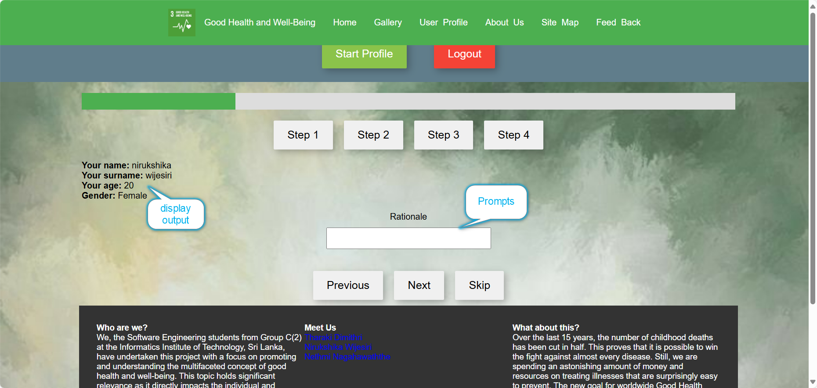

B.1.2 User Profile Page figure 02

**Team Page – team.html**

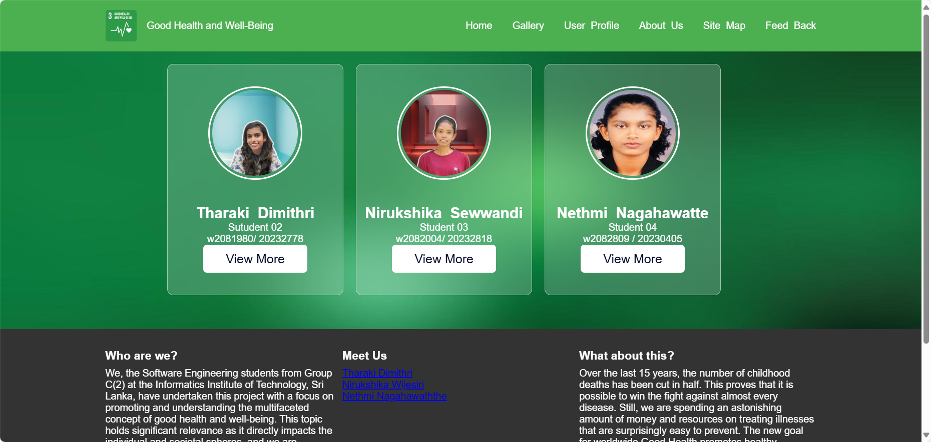

B.2.1.Team Page figure 03

**Page Editor – nirukshika.html**

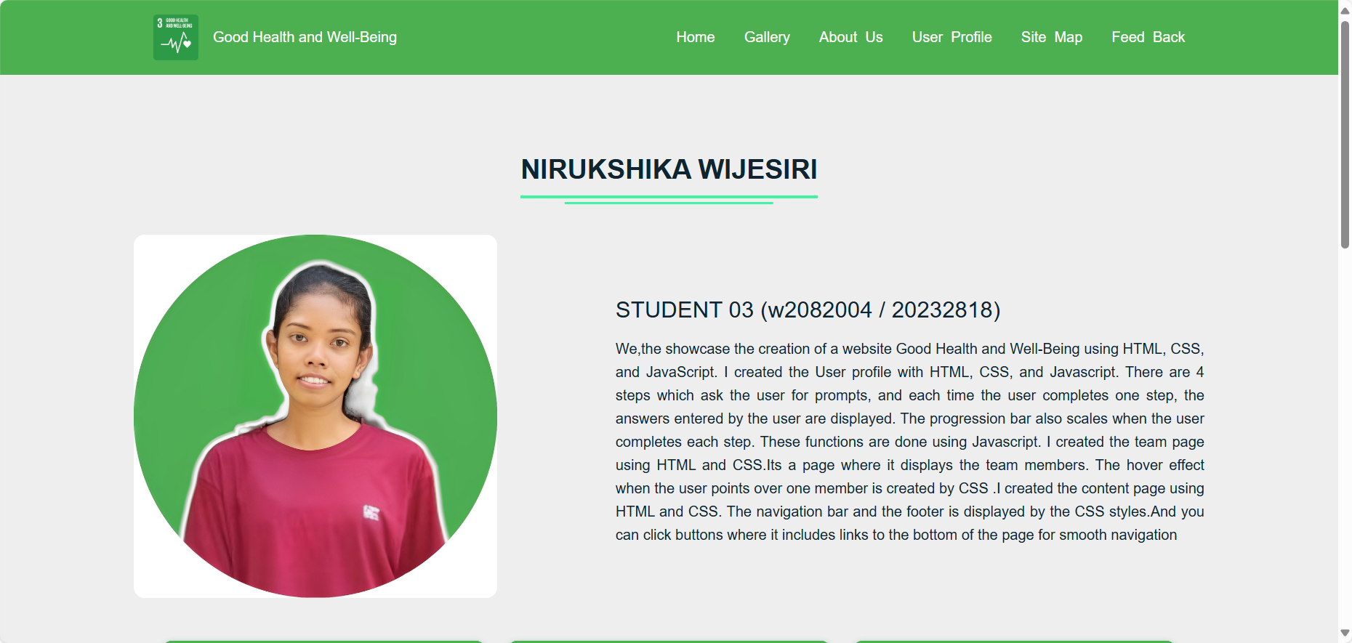

B.3.1. Page Editor figure 04

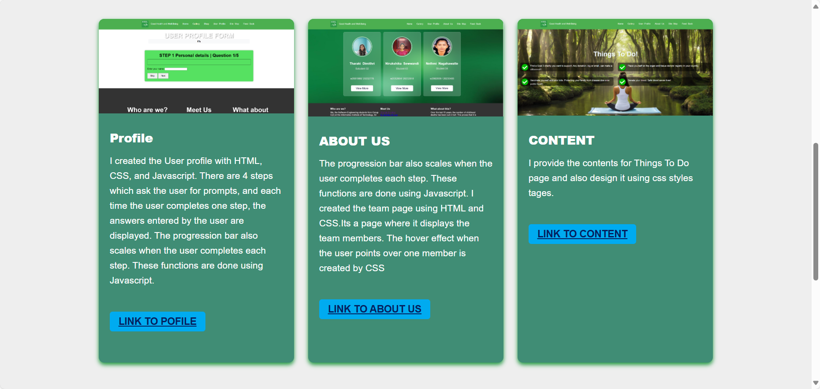

B.3.2. Page Editor figure 05

**Content Page – nirukshika.html**

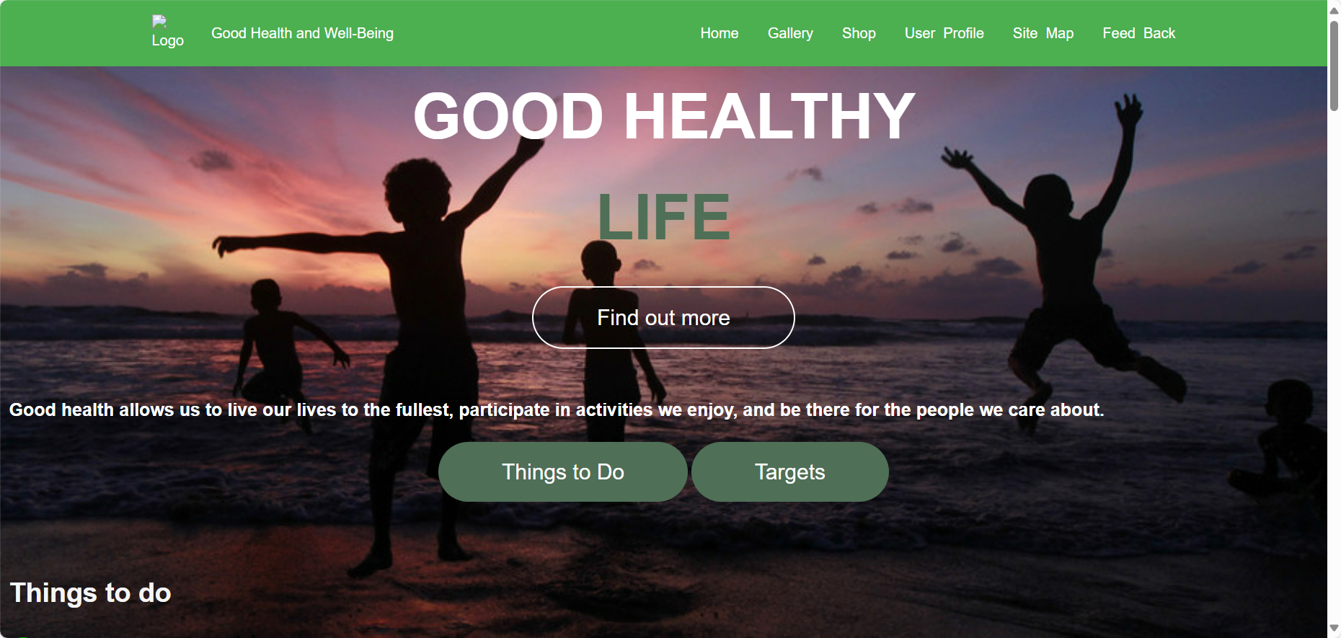

B.4.1.Content Page figure 06

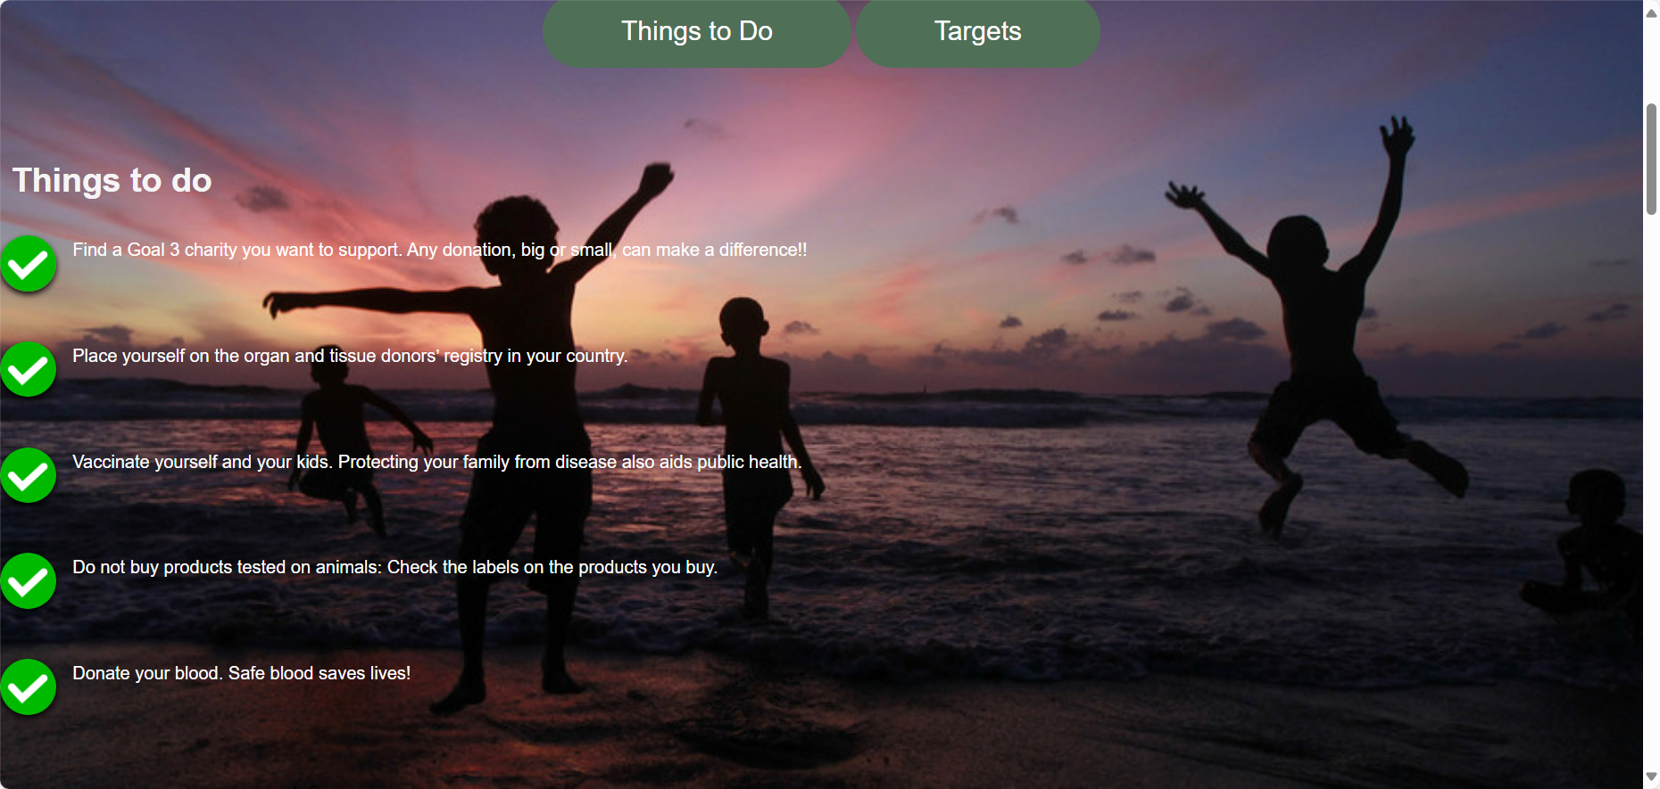

B.4.2.Content Page figure 07

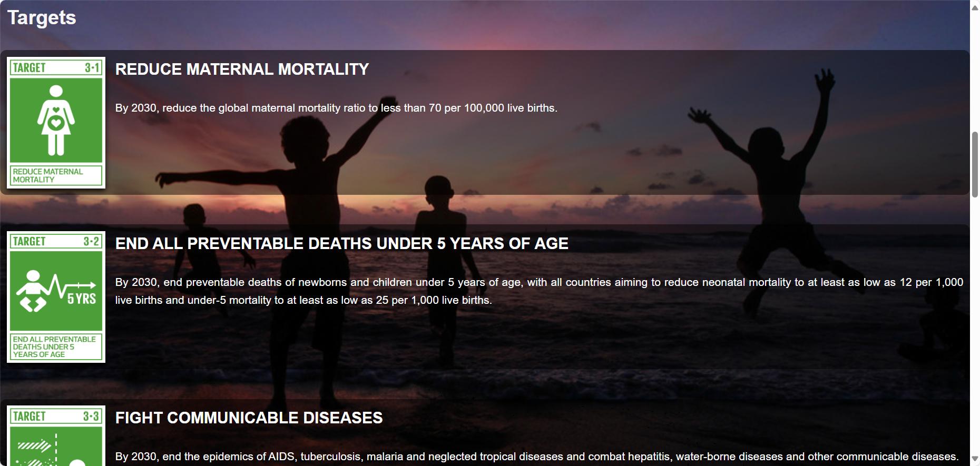

B.4.2.Content Page figure 08

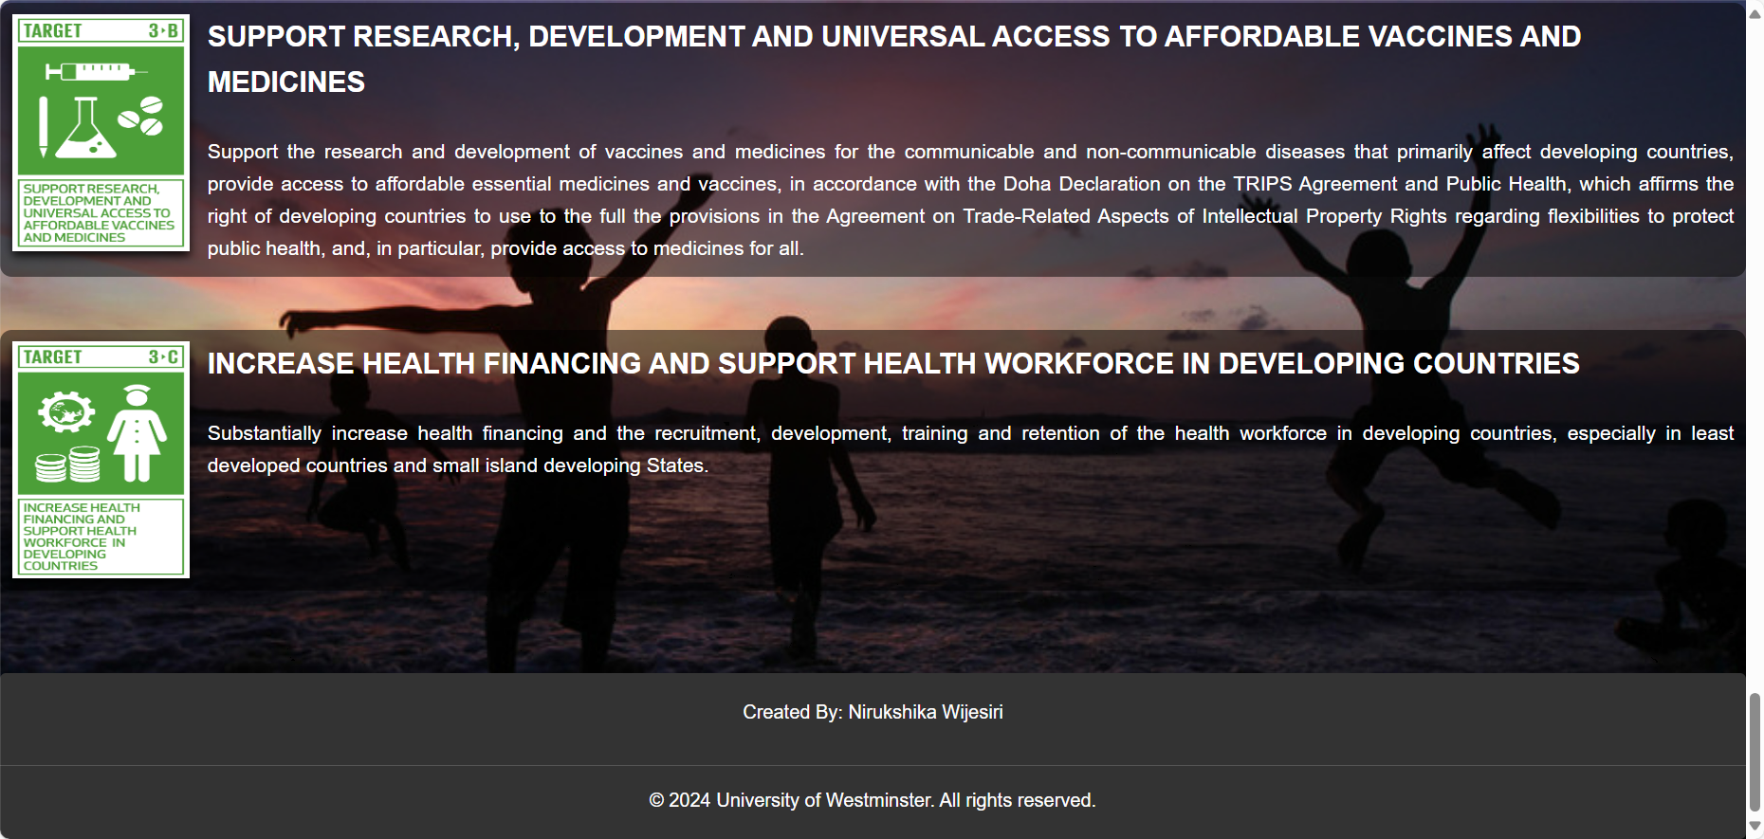

B.4.2.Content Page figure 09

## Appendix C: Screenshots - Webpage Validation Evidence

**Team page – team.html**

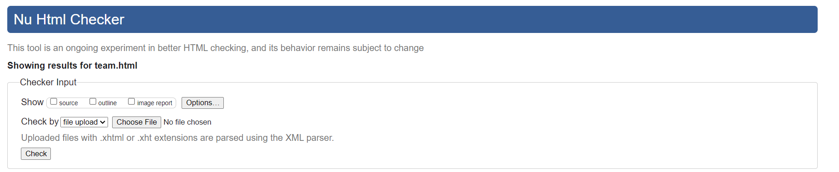

**User Profile Page – profile.html**

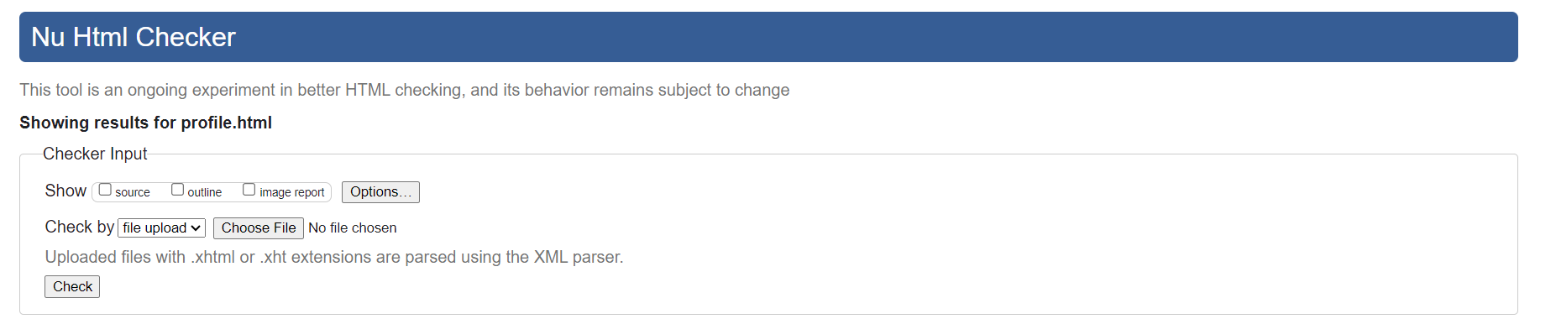

**Editor Page – Nirukshika.html**

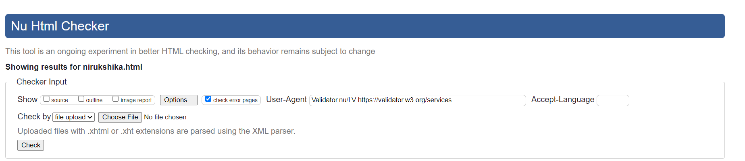

**Content Page – content_student3.html**

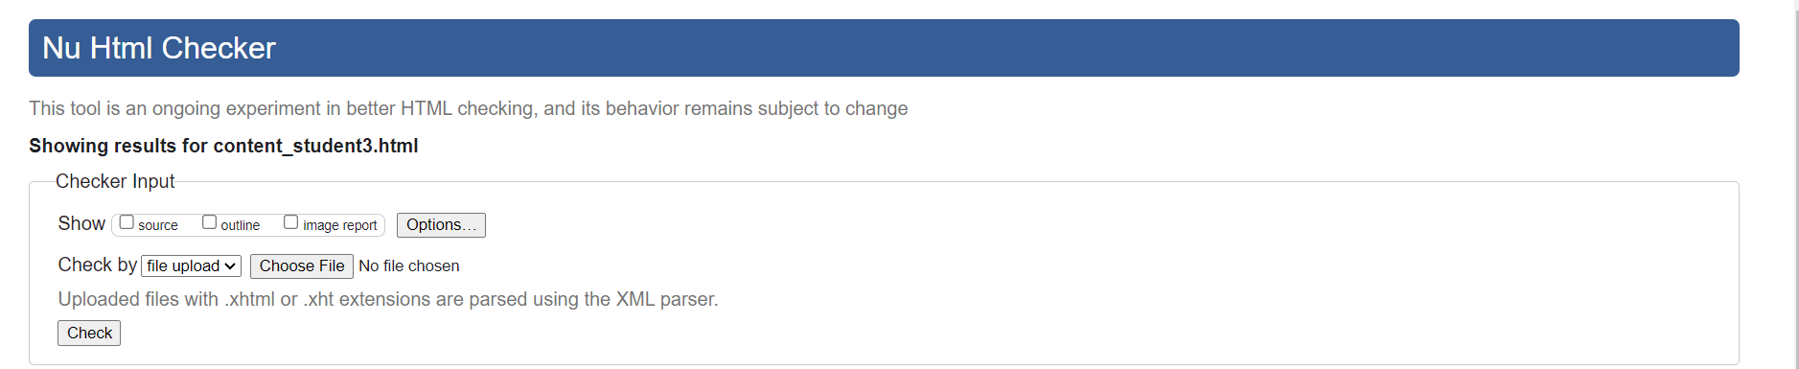



## Appendix D: Task Completion Checklist

|  |  |  |  |  |
| --- | --- | --- | --- | --- |
| **Student 3 Tasks** | **Completed** | | | **Student Comments** |
| **Yes** | **No** | **Partially** |
| 1 – User Profile | **\*** |  |  |  |
| 2 – Team | **\*** |  |  |  |
| 3 – Content page | **\*** |  |  |  |
| 4 – Page Editor | **\*** |  |  |  |
| 5 – Use of the provided navigation bar (adapted) | **\*** |  |  |  |
| 6 – Use of provided template (adapted) | **\*** |  |  |  |
| 7 – Additional CSS | **\*** |  |  |  |
| 8 – Additional Interactivity | **\*** |  |  |  |
| 9 – Uploaded to Webserver | **\*** |  |  |  |